1 / 4

**Zoo - Web Design - CA2**

Picture of website could go here

Link to our deployed website:

<https://sergio-oliveira-br.github.io/NCI-CA-Web-Design/>

Names of students:

Israel Roberto Parma – [x23175028@student.ncirl.ie](mailto:x23175028@student.ncirl.ie)

Maria Luiza Rodrigues Garcia – [x23157437@student.ncirl.ie](mailto:x23157437@student.ncirl.ie)

~~Nickolas Fernandes Franco -~~ [~~x23146991@student.ncirl.ie~~](mailto:x23146991@student.ncirl.ie)

Israel Roberto Parma – [x23175028@student.ncirl.ie](mailto:x23175028@student.ncirl.ie)

Sergio Vinicio da Silva Oliveira – [x23170981@student.ncirl.ie](mailto:x23170981@student.ncirl.ie)

Date:

07 Dec 2023

2 / 4

Table of Contents

1. Executive Summary ............................................................................................................ 1

2. Project Work ....................................................................................................................... 1

3. Design Process................................................................................................................... 1

4. Testing & Responsiveness ................................................................................................. 1

5. Conclusion .......................................................................................................................... 1

6. References.......................................................................................................................... 2

To update table of contents, right click, update field, then update entire table.

3 / 4

**1. Executive Summary**

**Why did you decide on this idea, what problem are you solving, what is the market size, etc.?  Provide an overview of your chosen company.**

Please use Harvard referencing if pulling material from the web about your chosen company or for any other material that you used in your document and you did create yourself. Sample reference: "according to  (Finance, 2015) there is a good idea to learn how to properly reference sources". NCI referencing guide - <https://libguides.ncirl.ie/referencingandavoidingplagiarism/harvard>. Put in here using the references tab here in Word or your own referencing manager software, e.g., [Mendeley](https://www.mendeley.com/), [Zotero](https://www.zotero.org/), [CiteThemRight](https://www.citethemrightonline.com/" \t "_blank), etc.

Also, pop in the link to your deployed website.

<https://sergio-oliveira-br.github.io/NCI-CA-Web-Design/index.html>

<https://github.com/sergio-oliveira-br/NCI-CA-Web-Design>

**2. Project Work**

How did your team split the project work? Show work packages with milestones and deliverables.

Initially, the project included four members, but unfortunately, due to personal problems, Nickolas Franco dropped out of the course.

In this first alignment, as the project requires, we designed something that covered eight pages, following an approach that demonstrated a zoological web page.

* Home / About Us / Overview - Israel
* Night Stroll - Nickolas
* Safari - Nickolas
* Gallery / Open Word - Sergio
* Meet our team - Sergio
* Gift Shop - Maria Luiza
* Form / Work with us - Maria Luiza
* Contact us / Map - Israel

After the announcement of the withdrawal of the team members, adjustments were made to adapt to the current reality to meet the project requirements.

The version appended in this report followed the following approach.

* Home / About Us / Overview - Israel
* ~~Night Stroll – Nickolas~~
* ~~Safari - Nickolas~~
* Gallery / ~~Open Word~~ / Safari - Sergio
* Meet our team / Game - Sergio
* Gift Shop - Maria Luiza
* Form / Work with us - Maria Luiza
* Contact us / Map – Israel

Based on this adjusted proposal, we had to mobilize to ensure that all pages we created met all the project's requirements. For this reason, we also had to change the mode of operation, changing the responsibilities, and assigned tasks according to the skills and affinity of each one.

**3. Design Process**

Colour palette, fonts used, buttons used etc. Lots of images and reasons why certain things were done the way they are presented on your website. Show wireframes for each web page and reference at least one design pattern per wireframe.

The design process was carried out independently by page, which means each page and its respective developers sought their references autonomously. This fact has provided us with an evolution of our understanding of teamwork.

In short, as we evolved in the assigned design phase, colour, font, and images, we realized that an initial alignment was essential so that we could promote harmony between the pages.

Facing the zoo theme, we sought images to allude to the proposal, therefore, Lexica.Art and Designer.Microsoft.com, were the references used in image acquisition. It comes to mind that ImageOptimizer.net optimized all images. The images were contextualized with the help of Chat.OpenAI.com.

In possession of the images, Canvas.com Colour Pallets helped us with the association and colour assignment of the pages.

We use W3Schools.com and GetBootstrap.com. In addition to the materials presented in the classroom to build the pages.

Regarding the choice adopted for the JavaScript minigame, it is due to the reason that we had already done it during the software development classes. Furthermore, we have achieved a significant reduction at this stage of development.

Web Page - <https://lexica.art>

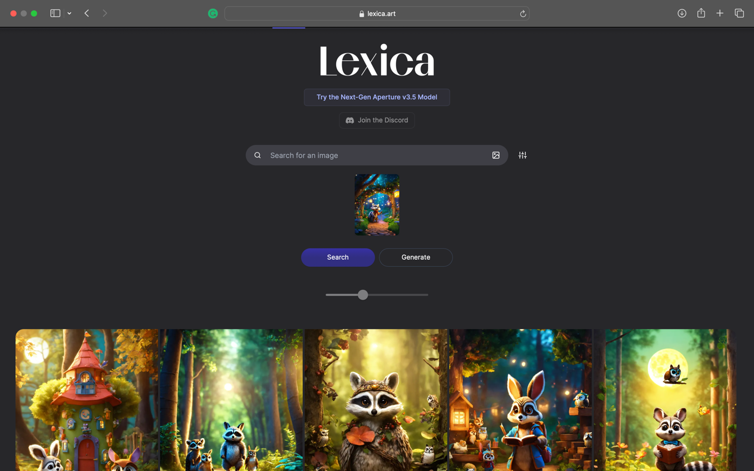

Web Page | Designer Microsoft - <https://designer.microsoft.com>

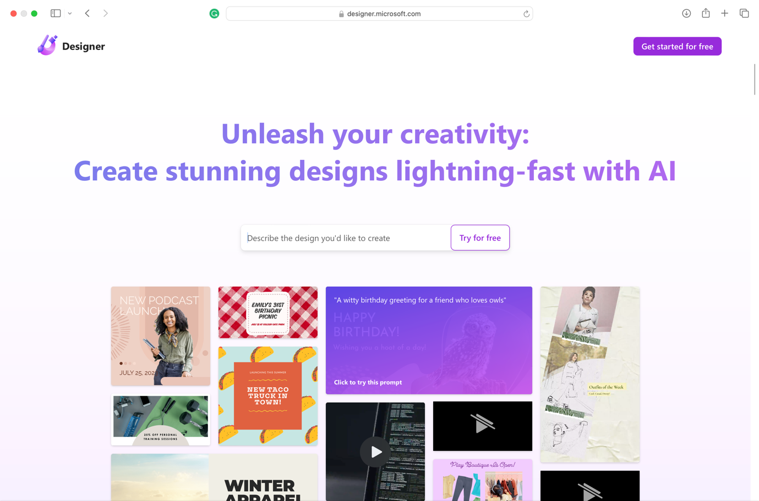

Web Page - <https://www.canva.com/colors/color-palette-generator/>

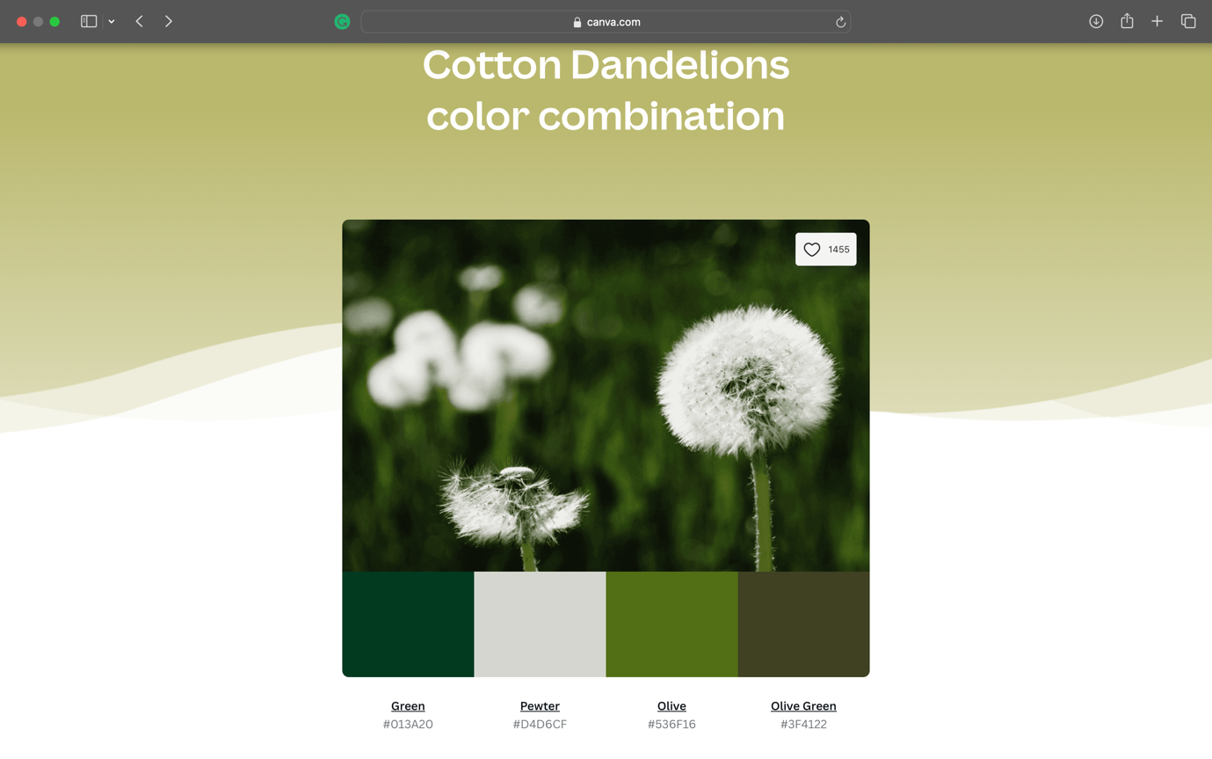

Web Page NCI – Moodle Page - <https://moodle2023.ncirl.ie/course/view.php?id=1053&section=4#module-20092>

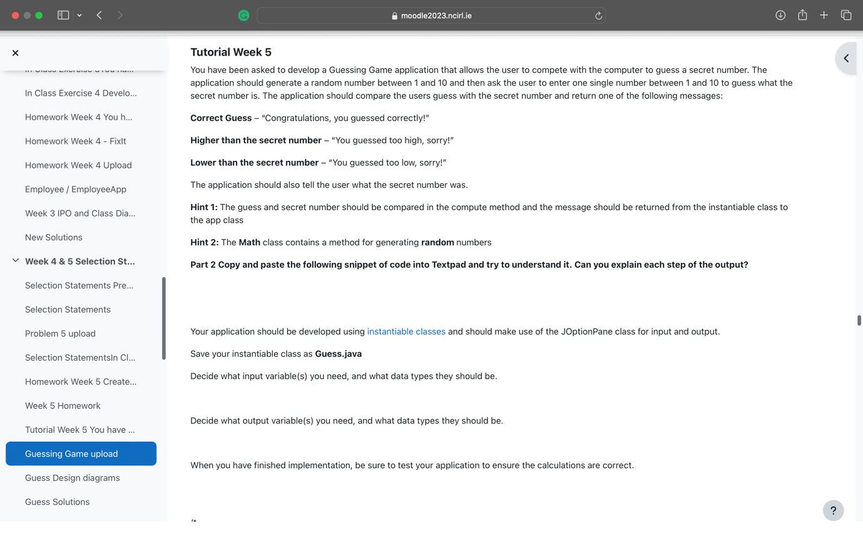

Web Page – Bootstrap <https://getbootstrap.com>

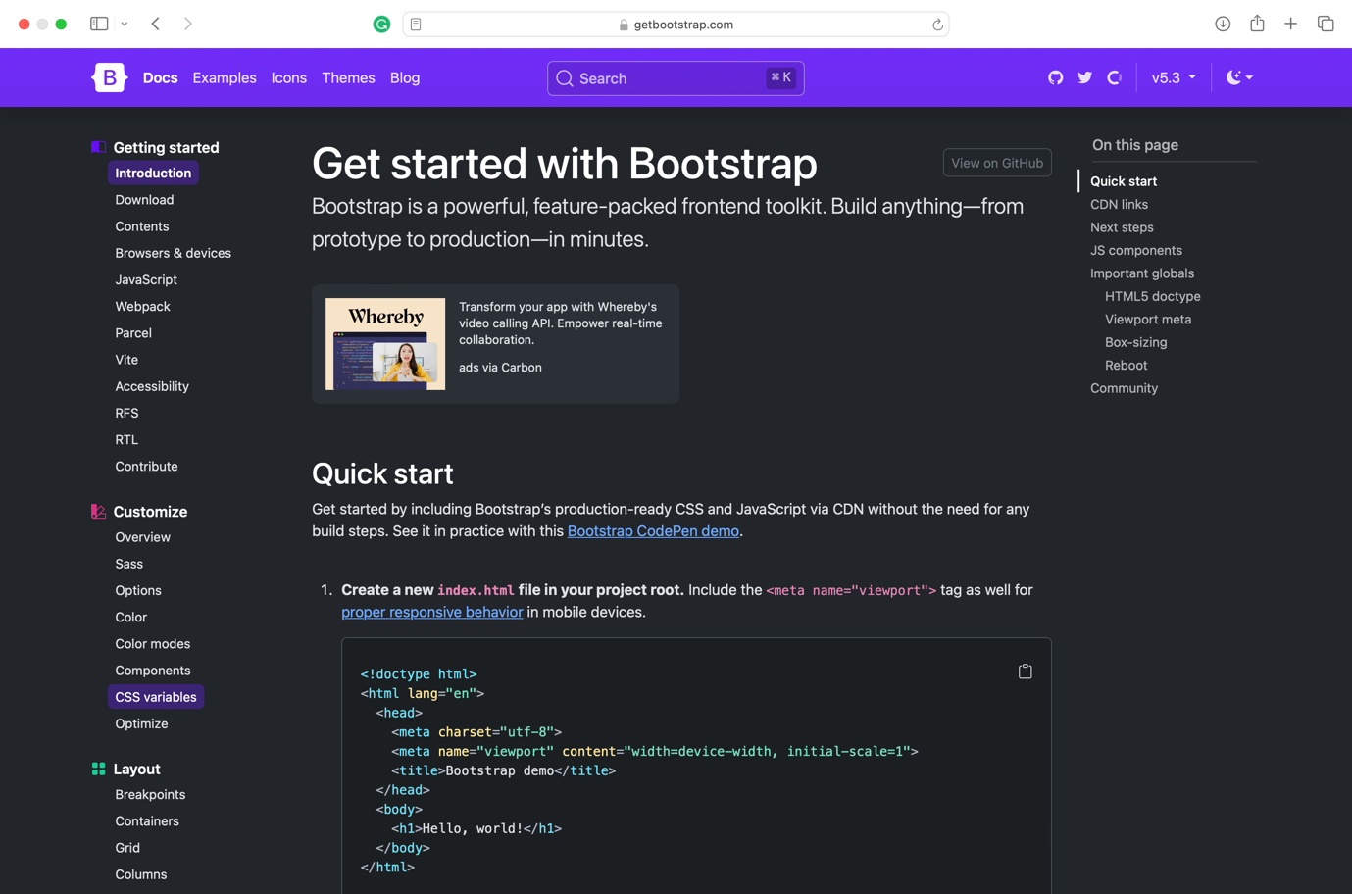

Wireframe – Index Page



Wireframe – Page Gallery & Safari



Wireframe – Page Our Team (popup)



Wireframe – Page Our Team



Wireframe – Game 

Wireframe – Gift Shop



Wireframe – Contact Us



**4. Testing & Responsiveness**

Talk about website responsiveness here along with **Optimisation, SEO and Testing**. You can talk about how you made your website responsive. You could also mention how you used JavaScript: loops, if statements, etc. How you deployed your website?

As mentioned earlier, the web page is available online and has been implemented through GitHub.

The documents used to create the pages are accessible through <https://github.com/sergio-oliveira-br/NCI-CA-Web-Design> in a public repository.

In accordance with the project scope, all images were optimized to achieve the desired responsiveness.

Pages Speed has provided reports below to support this statement.

<https://pagespeed.web.dev/analysis/https-sergio-oliveira-br-github-io-NCI-CA-Web-Design-index-html/gocm501h16?form_factor=mobile>

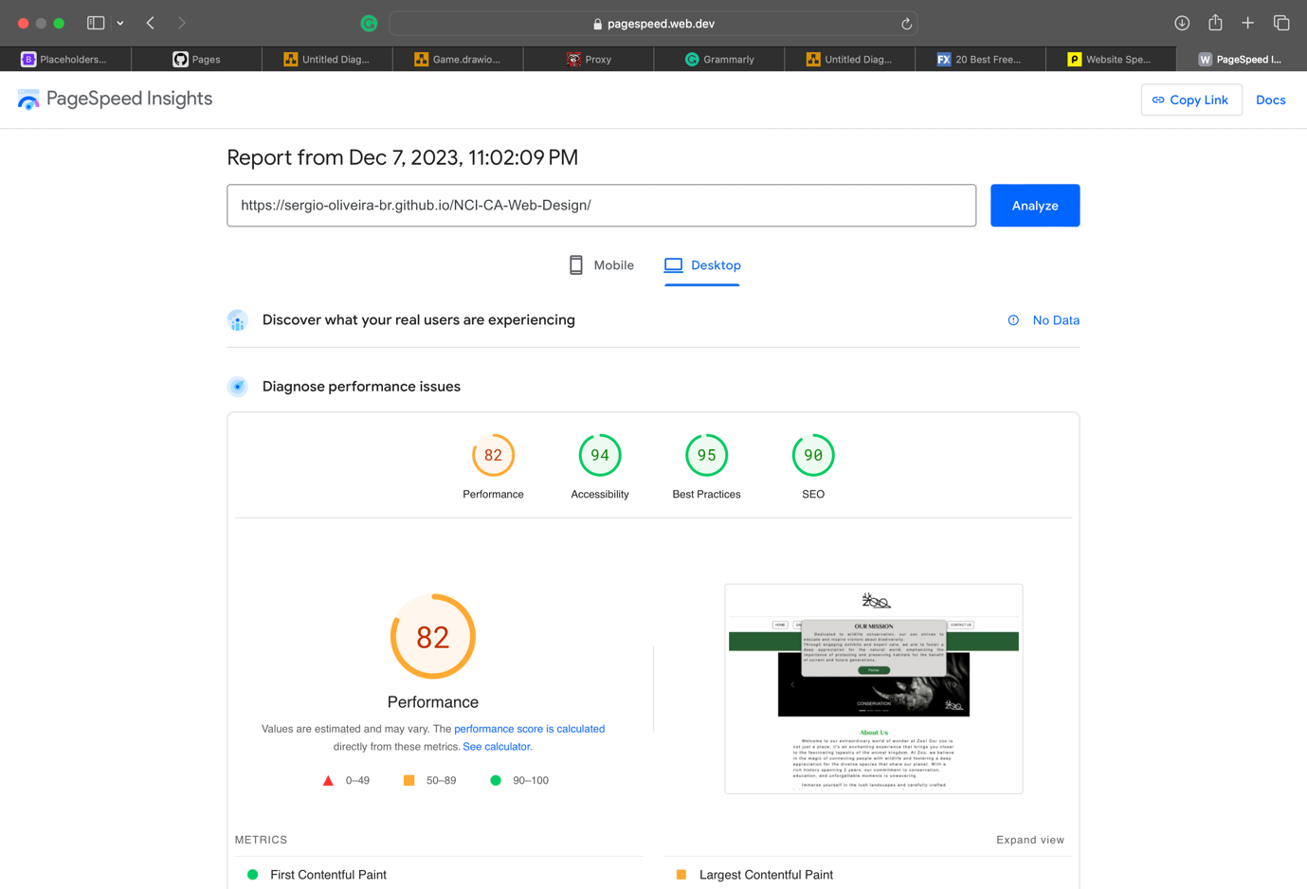

<https://pagespeed.web.dev/analysis/https-sergio-oliveira-br-github-io-NCI-CA-Web-Design-Pages-Gallery-html/6dnfguf6hp?form_factor=desktop>

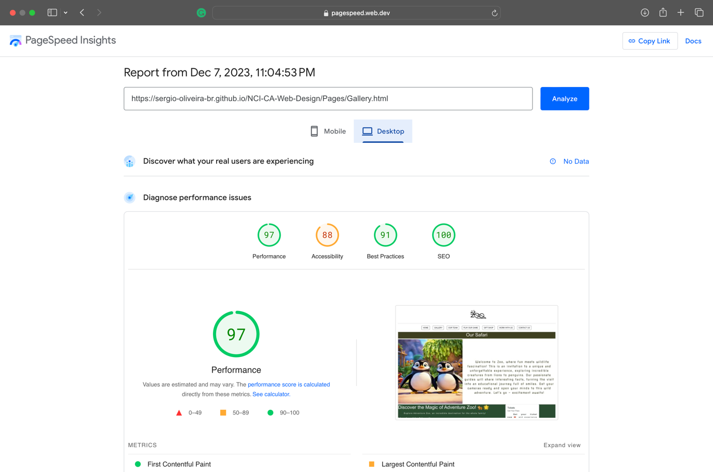

<https://pagespeed.web.dev/analysis/https-sergio-oliveira-br-github-io-NCI-CA-Web-Design-Pages-OurTeam-html/hel0je1qdf?form_factor=desktop>

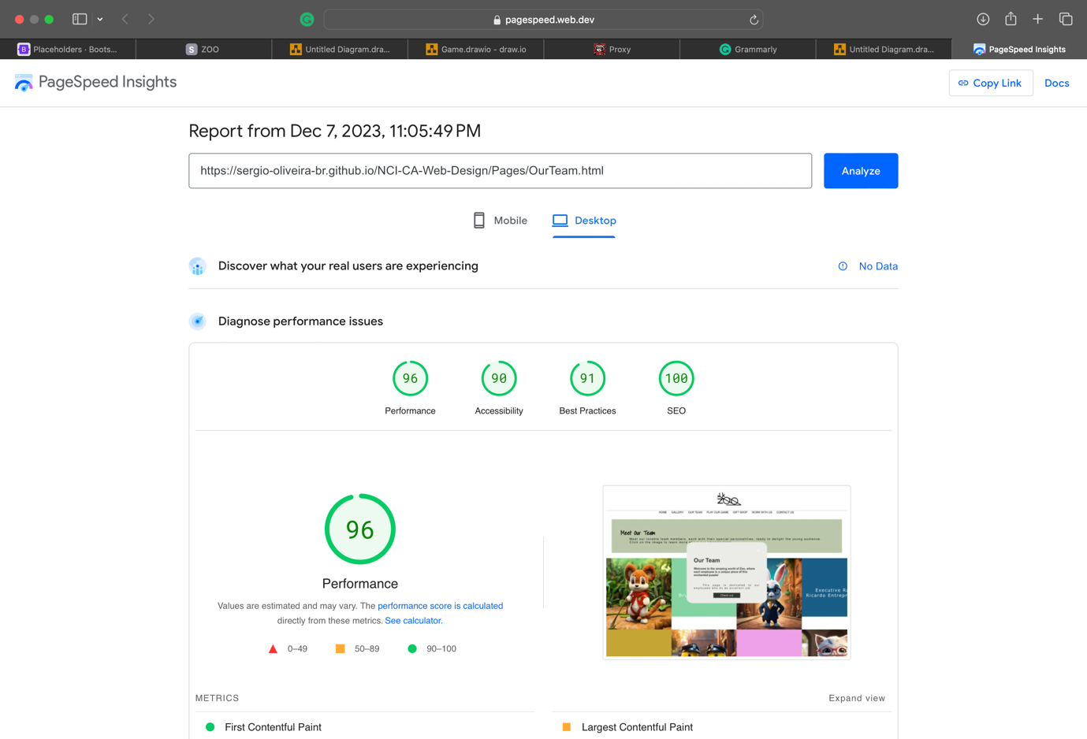

<https://pagespeed.web.dev/analysis/https-sergio-oliveira-br-github-io-NCI-CA-Web-Design-Pages-Game-html/4rmjp500vs?form_factor=desktop>

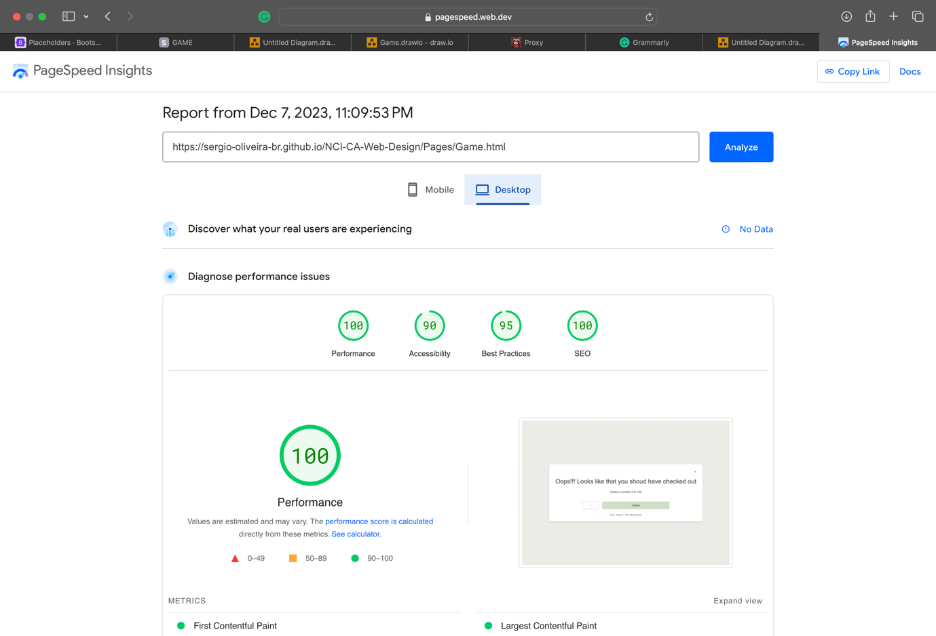

<https://pagespeed.web.dev/analysis/https-sergio-oliveira-br-github-io-NCI-CA-Web-Design-Pages-Gift-html/55ghj2xzxj?form_factor=desktop>

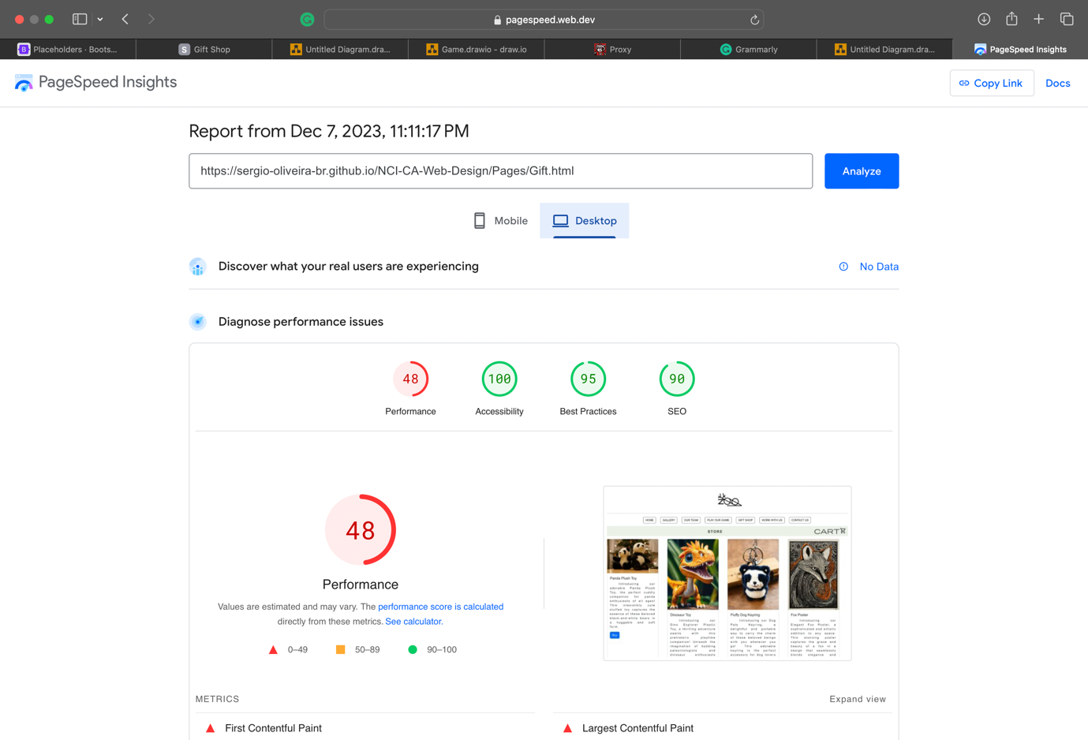

<https://pagespeed.web.dev/analysis/https-sergio-oliveira-br-github-io-NCI-CA-Web-Design-Pages-ContactUs-html/y3ufh3j2ds?form_factor=desktop>

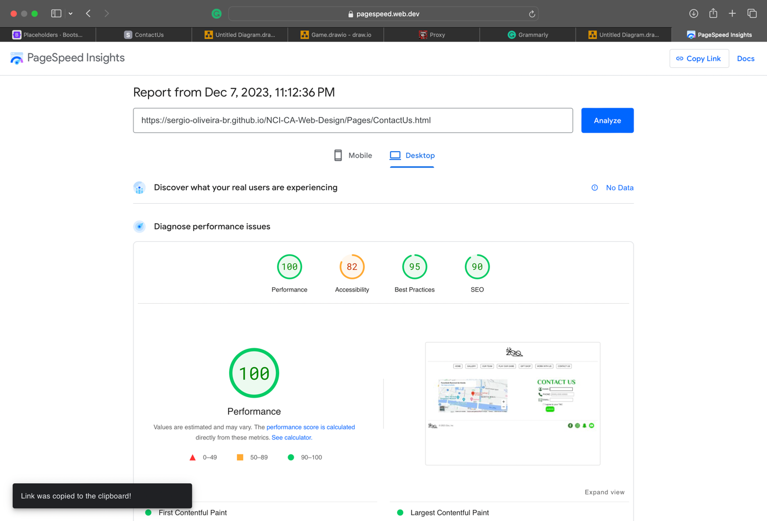

Page – Gallery | Flowchart of the buy button - link available ../Documents

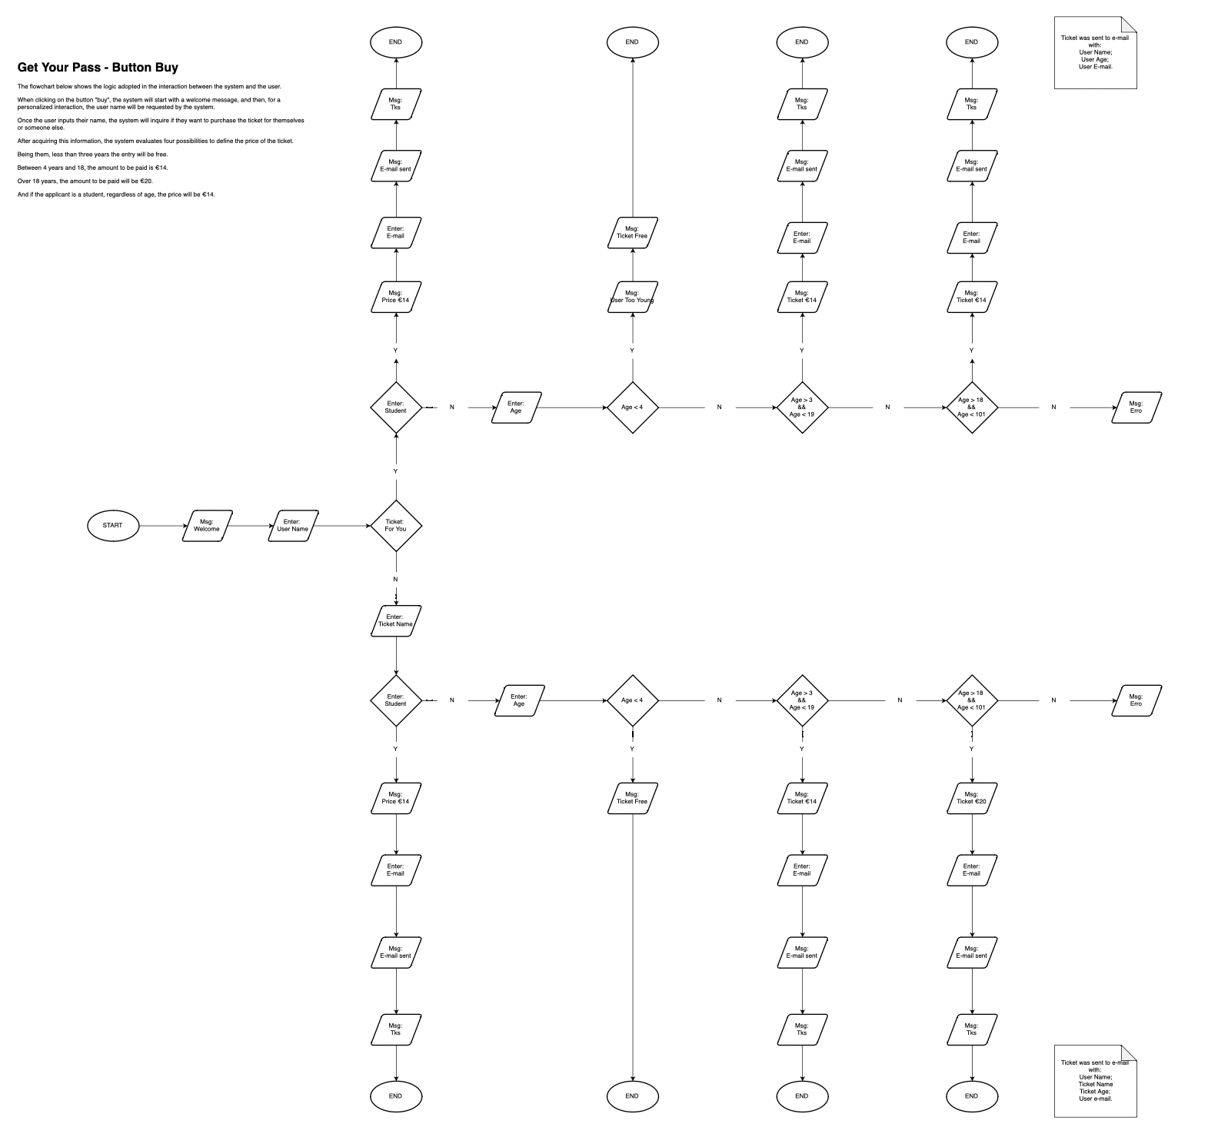

Page Gallery | Flowchart of the boot feedback



Flowchart – Game

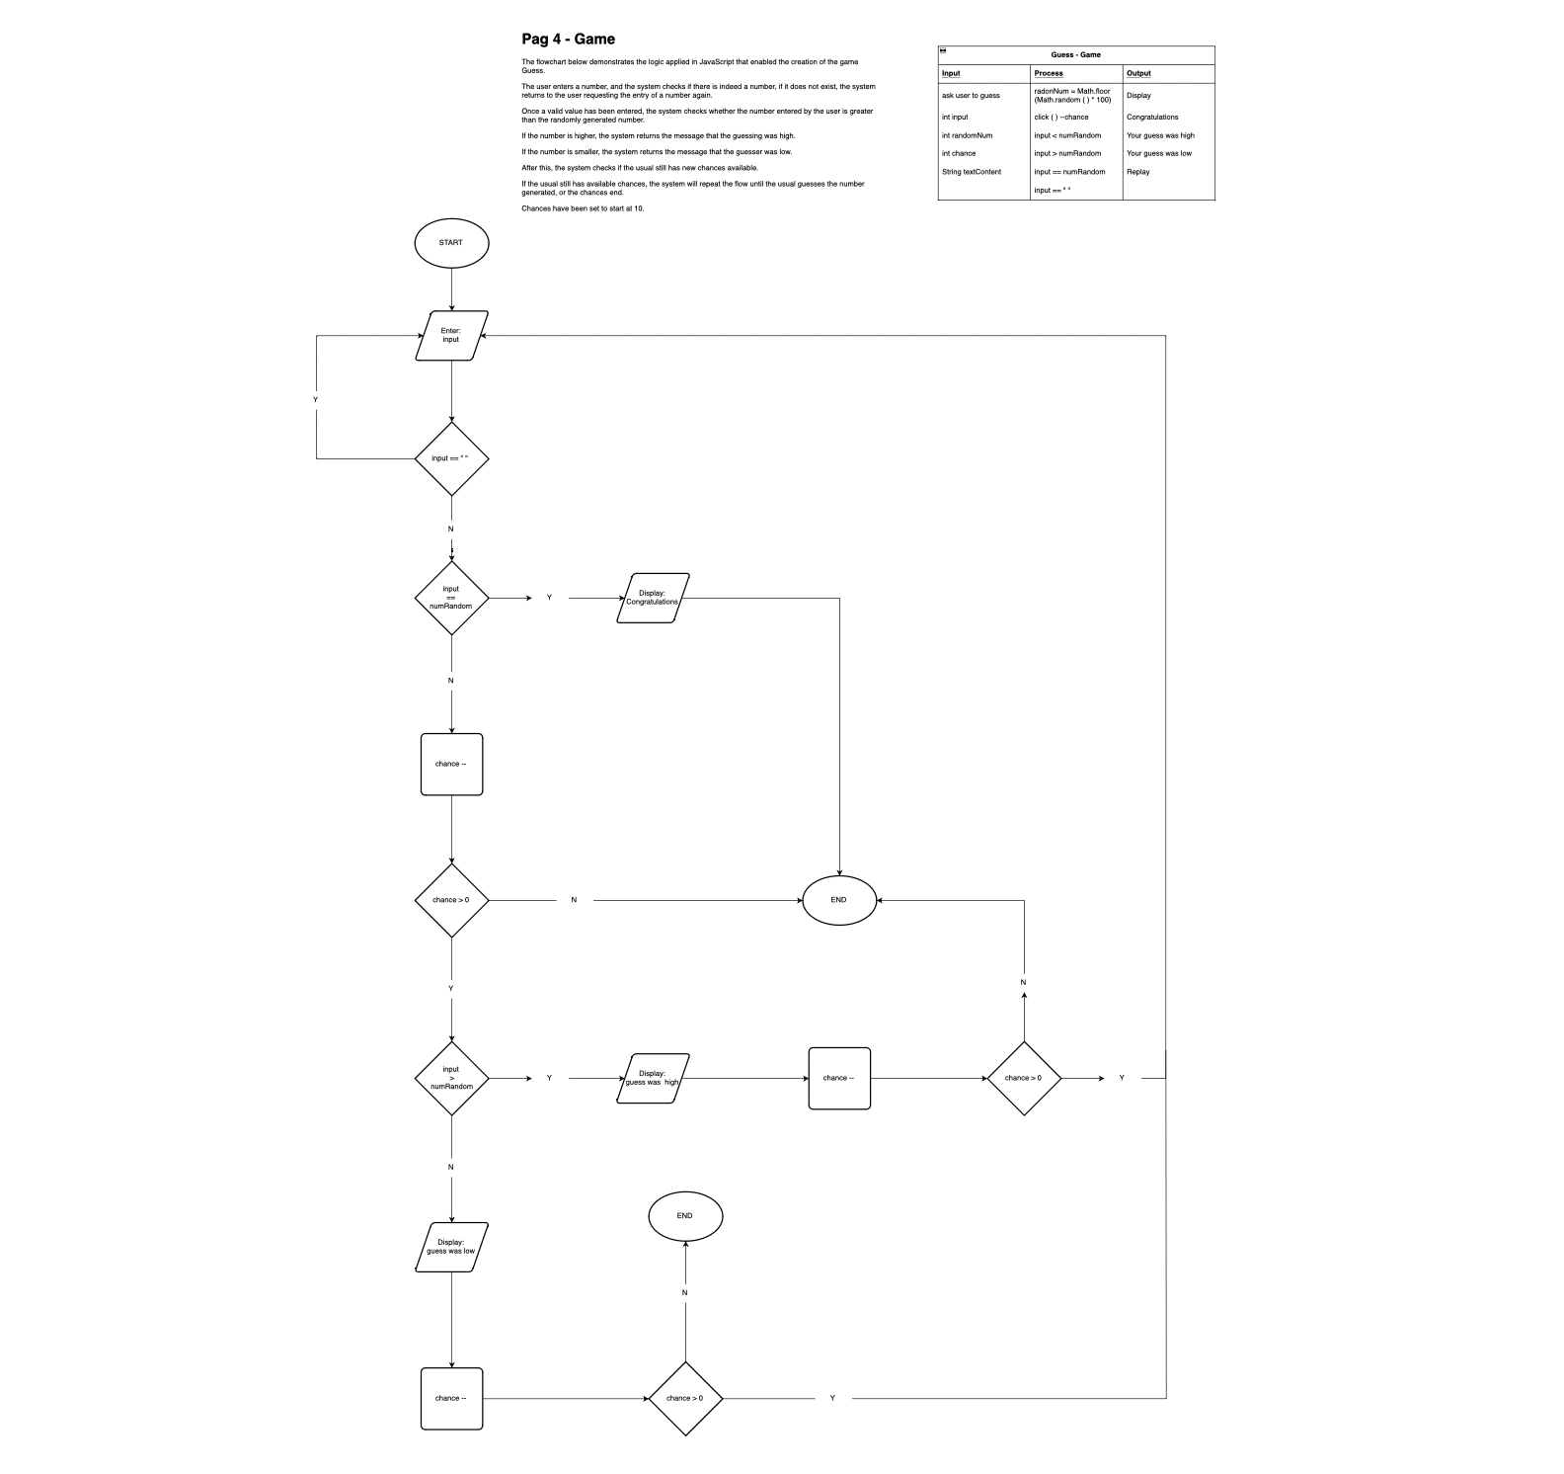

**5. Conclusion**

Overview of how the project went, did you work together well as a team? What was difficult to do, how you feel the website looks and if you had time, would you make any changes?

4 / 4

**6. References**

Finance, B. &., 2015. *Flexible working worth €2.5bn to Irish economy.*[Online]    
Available at: http://businessandfinance.com/news/flexible-working-worth-e2-5bn-to-irish-economy/    
[Accessed 8 March 2023].